Software Requirements Specifications

**(SRS)**

LED String Animation

Contents

Revision History Table: 4

Current Document State: 4

Project Description 5

Block Diagram 6

Feature Description 7

Reference Documents Table: - 9

# Revision History Table:

|  |  |  |  |
| --- | --- | --- | --- |
| Version | Author | Date | Status |
| 1.0 | Hesham – Mahmoud Gamal - Mark | 06/02/2020 | Initial Creation |

# Current Document State:

|  |  |  |  |
| --- | --- | --- | --- |
| **Date** | **Version** | **Document Status** | **Author** |
| 06/02/2020 | 1.0 | Proposed | Hesham – Mahmoud Gamal - Mark |

# Project Description

The project is composed of 3 sets of LED Strings Simulating the animation of LEDs in a Car.

One set is named “Tail” and it simulates the animation of car’s back LEDs while the other 2 sets are named “Left TI” and “Right TI” is simulating the animation of left and right turn indicator in a car.

Each one of the 3 functions operates based on input signals coming from 3 switches named “Tail Switch”, “Left TI” and “Right TI” respectively in addition to “Welcome Mode” which shall operates one of 2 different modes based on the status of the mode switch. System layout is as shown in **Figure 1** below.

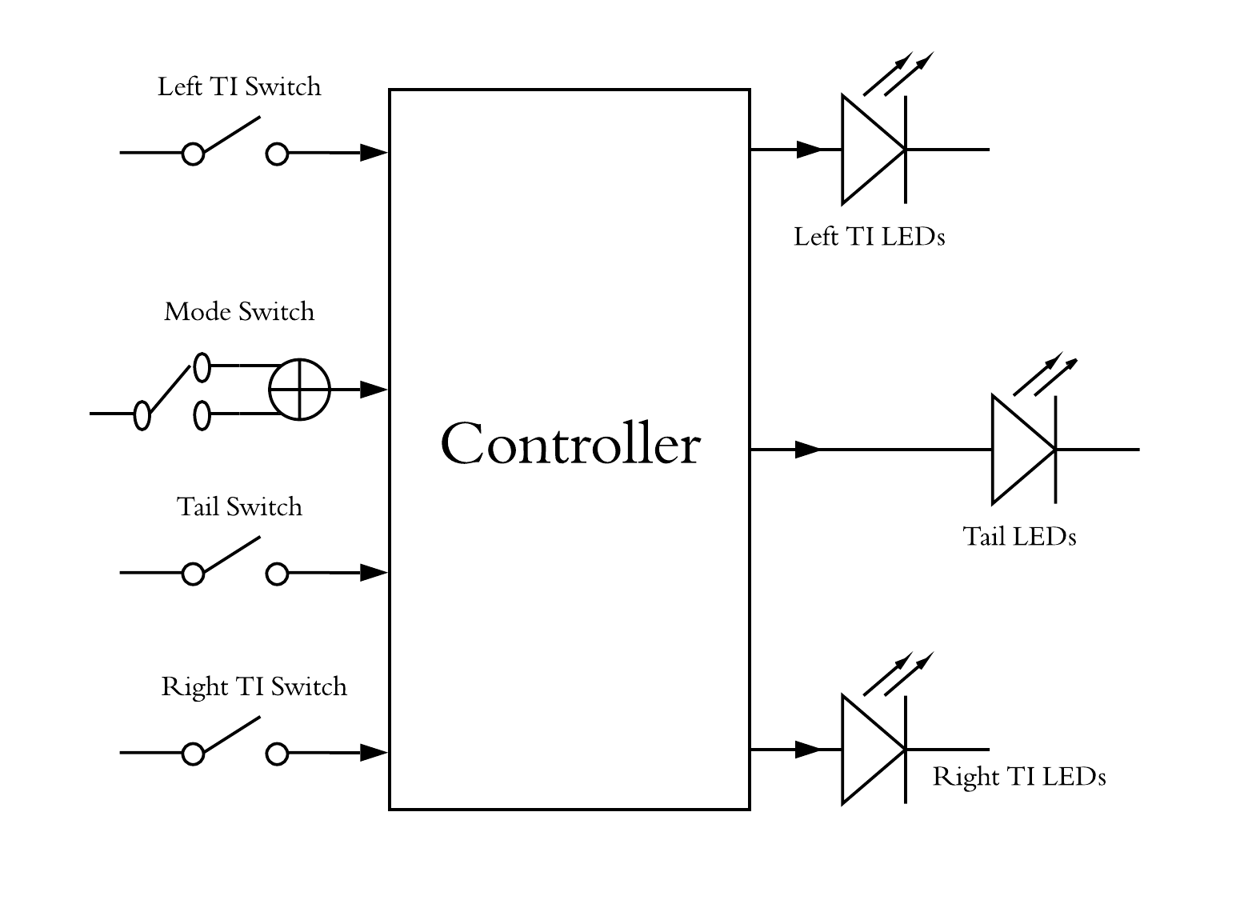

Figure 1: layout of the system

# Block Diagram

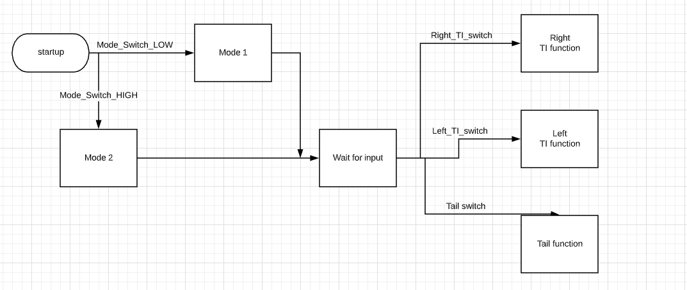

Fig. 2

# Feature Description

Start Up Requirements: -

* Req_ PO5_LSAN_ LED STRING ANIMATION_01_V01
  + Req_ PO5_LSAN_ SRS_Start animation mode 1_01-V01

SW shall read the pin switch status.

* + Req_ PO5_LSAN_ SRS_ Start animation mode 1_02-V01

SW shall set flag so as to start the MODE 1 function if the switch is pressed.

* + Req_ PO5_LSAN_ SRS_ Start animation mode 1_03-V01

SW shall start MODE 1 which is to switch on the 12 pins one by one from L6 to L1, then from R1 to R6 and vise versa. Then they all should switch on and off. A small delay, e.g. 100ms, shall be inserted between each change to be noticeable and smooth.

* Req_ PO5_LSAN_ LED STRING ANIMATION_02_V01
  + Req_ PO5_LSAN_ SRS_Start animation mode 2_01-V01

SW shall read the pin switch status.

* + Req_ PO5_LSAN_ SRS_ Start animation mode 2_02-V01

SW shall reset flag so as to start the MODE 2 function if the switch is released.

* + Req_ PO5_LSAN_ SRS_ Start animation mode 2_03-V01

SW shall start MODE 1 which is to switch on the 12 pins one by one from L1 to L6, simultaneously with R1 to R6 . Then repeat this scenario again. A small delay, e.g. 100ms, shall be inserted between each change to be noticeable and smooth.

Tail Function Description: -

* Req_ PO5_LSAN_ LED STRING ANIMATION_03_V01
  + Req_ PO5_LSAN_ SRS_Tail Function High_01-V01

SW shall read tail switch.

* + Req_ PO5_LSAN_ SRS_Tail Function High _02-V01

If the signal is HIGH, then Tail Pins shall be activated.

* + Req_ PO5_LSAN_ SRS_Tail Function High _03-V01

Wait until the signal is changed.

* Req_ PO5_LSAN_ LED STRING ANIMATION_04_V01
  + Req_ PO5_LSAN_ SRS_Tail Function Low_01-V01

SW shall read tail switch.

* + Req_ PO5_LSAN_ SRS_Tail Function Low _02-V01

If the signal is LOW, then Tail Pins shall be deactivated.

* + Req_ PO5_LSAN_ SRS_Tail Function Low _03-V01

Wait until the signal is changed.

Turn Indicator (TI) Function Description

* Req_ PO5_LSAN_ LED STRING ANIMATION_05_V01
  + Req_ PO5_LSAN_ SRS_Right Turn Indicator On_01-V01

SW shall read the right TI switch pin status.

* + Req_ PO5_LSAN_ SRS_Right Turn Indicator On_02-V01

If the signal is HIGH, then right pins TI animation shall be activated.

-R1 (100 ms) > R1+R2(100 ms) > R1+R2+R3(100 ms) > …,etc.

-Turn off Leds

-Repeat.

* + Req_ PO5_LSAN_ SRS_Right Turn Indicator On_03-V01

Wait until the signal is changed.

* Req_ PO5_LSAN_ LED STRING ANIMATION_05_V02
  + Req_ PO5_LSAN_ SRS_Right Turn Indicator Off_01-V01

SW shall read the right TI switch pin status.

* + Req_ PO5_LSAN_ SRS_Right Turn Indicator On_02-V01

If the signal is LOW, then right pins TI animation shall be deactivated.

* + Req_ PO5_LSAN_ SRS_Right Turn Indicator Off_03-V01

Wait until the signal is changed.

* Req_ PO5_LSAN_ LED STRING ANIMATION_05_V03
  + Req_ PO5_LSAN_ SRS_Left Turn Indicator On_01-V01

SW shall read the left TI switch pin status.

* + Req_ PO5_LSAN_ SRS_ Left Turn Indicator On_02-V01

If the signal is HIGH, then left pins TI animation shall be activated.

-L1 (100 ms) > L1+L2(100 ms) > L1+L2+L3(100 ms) > …,etc.

-Turn off Leds

-Repeat.

* + Req_ PO5_LSAN_ SRS_ Left Turn Indicator On_03-V01

Wait until the signal is changed.

* Req_ PO5_LSAN_ LED STRING ANIMATION_05_V04
  + Req_ PO5_LSAN_ SRS_ Left Turn Indicator Off_01-V01

SW shall read the Left TI switch pin status.

* + Req_ PO5_LSAN_ SRS_ Left Turn Indicator On_02-V01

If the signal is LOW, then Left pins TI animation shall be deactivated.

* + Req_ PO5_LSAN_ SRS_ Left Turn Indicator Off_03-V01

Wait until the signal is changed.

# Reference Documents Table: -

|  |  |  |  |
| --- | --- | --- | --- |
| Ref. number | Doc. Name | Version | Status |
| 1 | LED_STRING_ANIMATION_CYRS | 1.2 | Proposed |